**1.Junit Basic Testing Exercises**

**Exercise 1: Setting Up Junit**

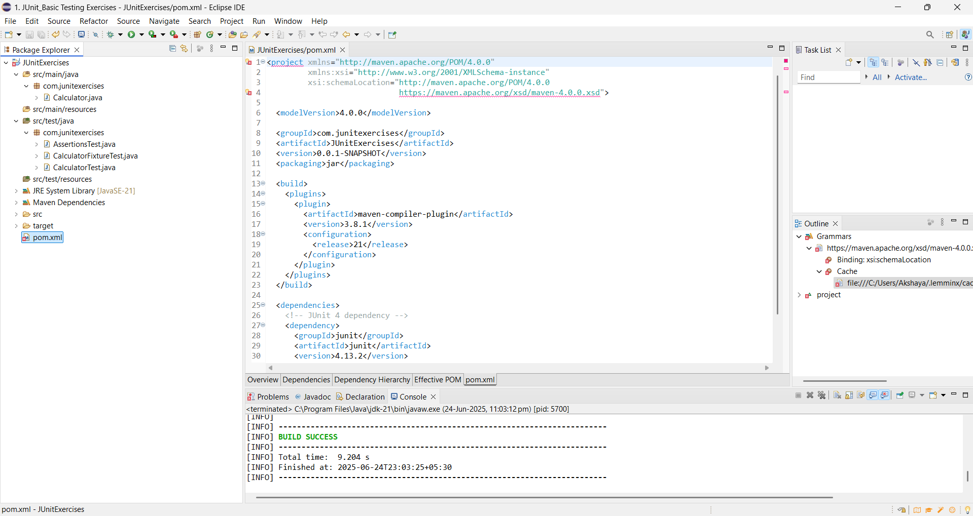

**Exercise 2: Writing Basic JUnit Tests**

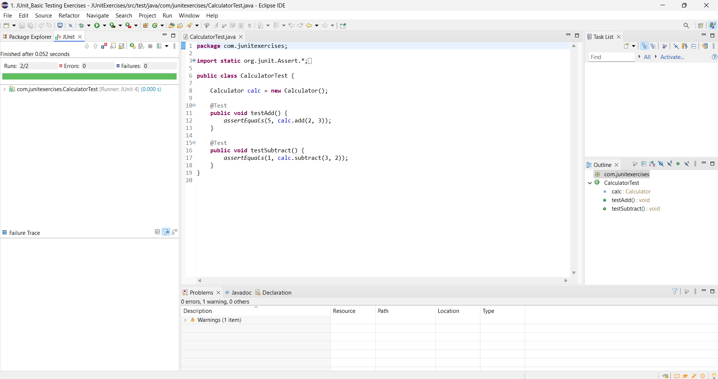

**Exercise 3: Assertions in JUnit**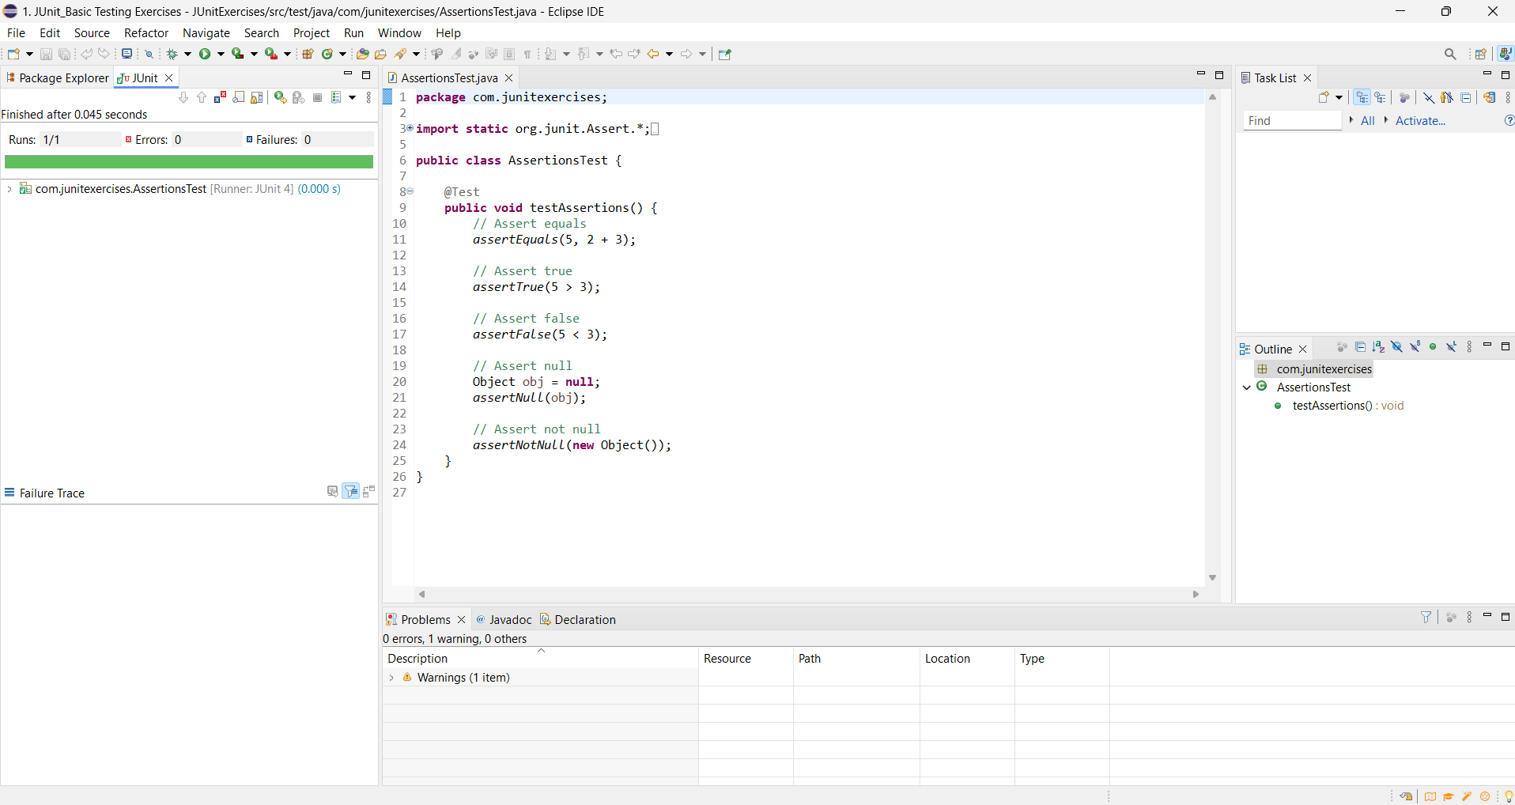

**Exercise 4: Arrange-Act-Assert (AAA) Pattern, Test Fixtures, Setup and Teardown Methods in Junit**

